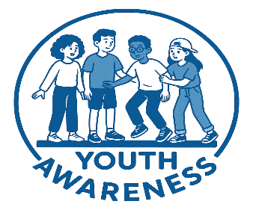**STEP BY STEP GUIDE – YOUTH AWARENESS DAY 16TH OCTOBER**

1. Register interest by emailing [youthawarenessday@gmail.com](mailto:youthawarenessday@gmail.com) giving school name and contact detail.
2. Play to students the video Presentation (one for primary schoolchildren and one for secondary respectively) see Google Drive File
3. Secondary schools play and circulate amongst students and on social media this video -<https://vimeo.com/1114291968/b985f2aeeb?ts=0&share=copy> .
4. Send to parents the High Sheriff letter (PDF in Google Drive link below).
5. Please post Posters PDF in Google Drive file– Note there is one designed for primary schools. Printed posters are available if requested.
6. Plan an extra fundraising activity if you can.
7. Encourage students to wear blue on 16th October and donate what they can afford.
8. Keep us posted on social media of all activities being planned – send photos of the young wearing blue on the day
9. Please pay any funds raised to the specially created and permanent youth fund being managed by the Shropshire Community Foundation go to [www.shropshirecommunityfoundation.org.uk/youth-awareness-day/](http://www.shropshirecommunityfoundation.org.uk/youth-awareness-day/) or pay into the Just Giving account <https://www.justgiving.com/page/youth-awareness-day>. Please note payments direct to the Foundation are preferred as there are no charges on taking the donation.

**NOTE All Relevant Documents are Contained in this Google Drive File https://drive.google.com/drive/folders/1PegUO4RnYGULOqZ4dYEw2ZspsyUn6Mgj**

If you cannot access the information or have any queries, please contact me on [shropshire@highsheriffs.com](mailto:shropshire@highsheriffs.com)